DATE:10.10.2023

PROJECT ID: Proj_223331_Team_2

PROJECT NAME: Smart water fountains

PHASE II **INNOVATION** (smart water fountains)

**INTRODUCTION**

Smart water fountains are technologically enhanced water dispensers that often incorporate features such as touchless operation, water purification systems, sensors to monitor water quality, and connectivity to enable remote control or data collection. These fountains are designed to provide convenient and efficient access to drinking water while promoting sustainability and hygiene through advanced capabilities.

**SOLVING FOR SMART WATER FOUNTAINS**

Advanced techniques for solving the problem of smart water fountains include:

* 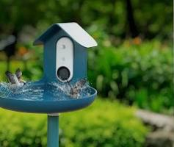**Using artificial intelligence (AI) to monitor water quality and consumption.** Al-powered smart water fountains can monitor water quality in real time and detect any contaminants. They can also track water consumption and identify patterns of use. This information can be used to improve water quality, reduce water consumption, and identify potential problems.
* 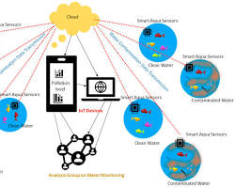**Using lot sensors to monitor and control smart water fountains.** IoT sensors can be used to monitor various aspects of smart water fountains, such as water quality, temperature, and flow rate. This information can be used to control the fountain remotely and ensure that it is operating efficiently and effectively.
* 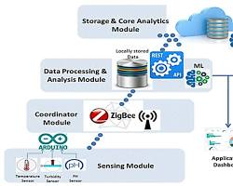**Using predictive analytics to forecast water demand and prevent problems.** Predictive analytics can be used to forecast water demand and identify potential problems before they occur. This information can be used to adjust the operation of the smart water fountain and prevent water shortages, leaks, and other problems.

## **STEP TO SOLVING FOR THE PROBLEM OF SMART WATER FOUNTAINS**

Solving the problem of smart water fountains involves several steps. Here’s a high-level overview

*Step 1: Define Objective*

• Clearly define what you want to achieve with smart water fountains, such as reducing water waste or enhancing user experience.

*Step 2: Research and Planning*

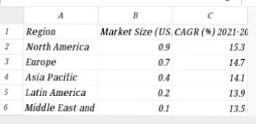Image: Market research data

• Research existing smart fountain technologies, market trends, and user preferences.

*Step 3: Design and Prototyping*

• Create design sketches or computer- aided design (CAD) models for the smart water fountain.

*Step 4: Hardware Development*

• Develop the physical components of the smart water fountain, including sensors, pumps, and water purification systems.

*Step 5: Software Development*

• Write software to control the fountain’s operation, interface with sensors, and provide user-friendly features.

*Step 6: Integration*

* Assemble the hardware and software components, ensuring they work together seamlessly.

*Step 7: Testing and Quality Assurance*

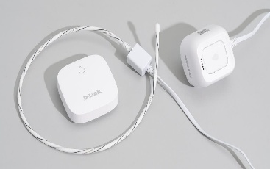 • Image: Testing setup

• Conduct thorough testing to ensure the fountain functions reliably and meets safety standards.

*Step 8: User Testing*

• Invite users to test the smart water fountain, gather feedback, and make improvements.

*Step 9: Manufacturing and Production*

* Set up manufacturing processes for mass production if necessary.

*Step 10: Deployment*

• Install smart water fountains in public spaces, offices, or wherever they are intended to be used.

*Step 11: Maintenance and Updates*

• Establish a maintenance schedule and plan for software updates to keep the fountains running smoothly.

*Step 12: Data Analysis and Optimization*

* Continuously collect data from the fountains to analyze usage patterns and optimize their performance.

*Step13:User Education and Engagement*

• Educate users on how to use the smart water fountains efficiently and promote sustainable water practices.

*Step 14: Sustainability Considerations*

* Ensure the smart fountains are eco- friendly and consider their environmental impact.

Throughout each step, it’s important to collaborate with experts in engineering, design, and user experience to create effective and user-friendly smart water fountains.